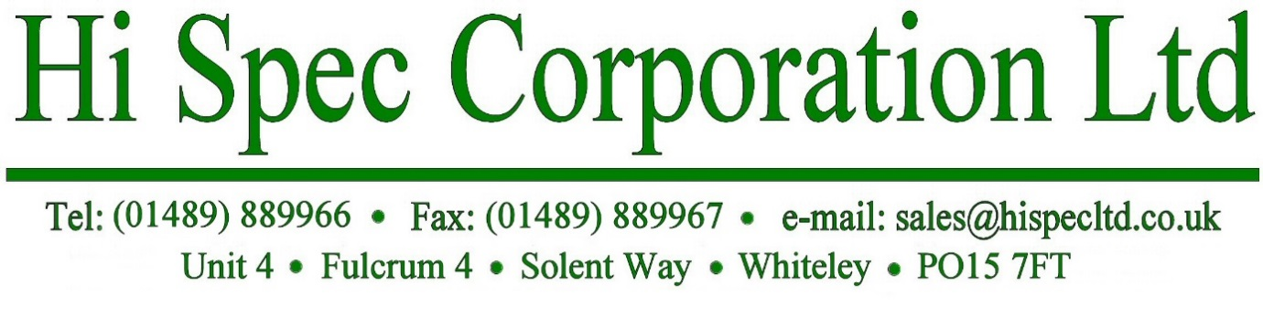

REGULATION (EC) No 1907/2006 CONCERNING:
THE REGISTRATION, EVALUATION, AUTHORISATION AND RESTRICTION OF CHEMICALS (REACH)

Hi Spec Corporation Limited confirm that none of its products or packaging contain any of the 233 Substances of Very High Concern (SVHC) on the REACH Candidate List issued on 17th January 2023 in a concentration above the 0.1% by weight allowable limit:

Signed : E Hare
Name (print) : Edward Hare

Position: : Operations Manager

Date: : 2nd February 2023

