PCB Shelf Life
Hi Spec recommend that the following guidelines for baking all PCBs prior to assembly are followed to guarantee good quality.
PCBs used after their recommended shelf life are used at our customers risk.
Please note with different finishes the storage shelf life should be followed as below :
- Tin or Tin-Lead HASL, Immersion Gold = 1 year (also shown in table below)
- Immersion Silver, Immersion Tin, OSP = 6 months (also shown in table below)
- PCBs that are out of Shelf Life specified are to be scrapped or baked. This is due to the moisture absorption of the material and the increased susceptibility to delamination during assembly of the PCB (for further details, refer to IPC-1601).
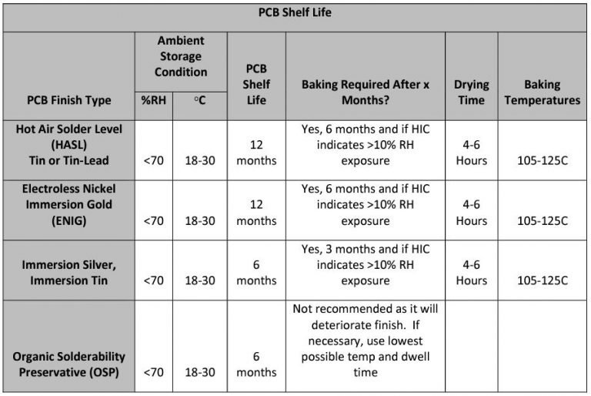
(HIC = Humidity indicator card)

