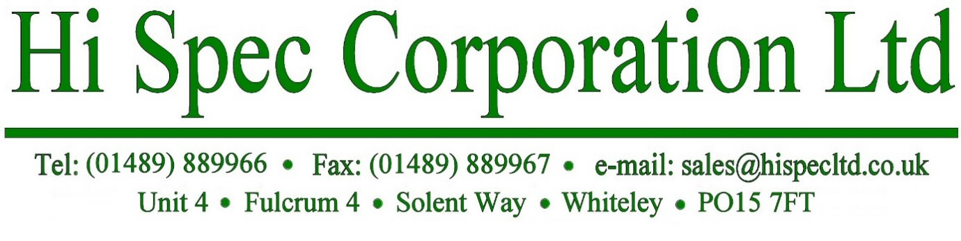

REGULATION (EC) No 1907/2006 CONCERNING:
THE REGISTRATION, EVALUATION, AUTHORISATION AND RESTRICTION OF CHEMICALS (REACH)

Hi Spec Corporation Limited confirm that none of its products or packaging contain any of the 247 Substances of Very High Concern (SVHC) on the REACH Candidate List issued on 21st January 2025 in a concentration above the 0.1% by weight allowable limit:

Signed : A Talley
Name (print) : Adrian Talley

Position: : Operations Assistant

Date: : 6th March 2025

